Building

Reflow Oven Notes
Christopher Kalitin

NTC100K Thermistor characterization:
https://docs.google.com/spreadsheets/d/1yqm948NJ8_uzt0267oY7HAHMM17IJyKlpiy86Fge3AQ/edit?gid=0#gid=0

SSR-25DA Datasheet:
https://cdn.sparkfun.com/datasheets/Components/General/SSR40DA.pdf

Github:
https://github.com/CKalitin/reflow-oven

Fine to drive the SSR directly from a GPIO:
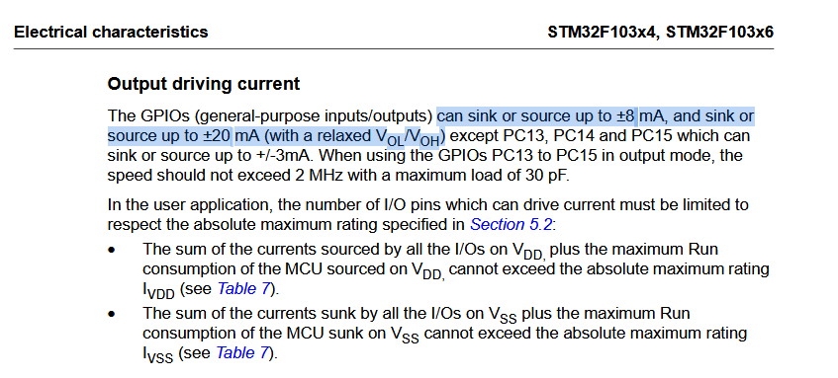

I need to account for ADC inaccuracy:

Sep 10 2025 - Code & First Run

From this characterization:
https://docs.google.com/spreadsheets/d/1U9BUFMx0slfPn3714AJLw4gdnrUlUOC_lumwhomHoFM/edit?gid=663711069#gid=663711069
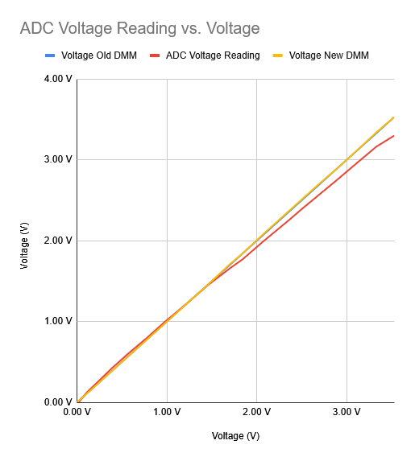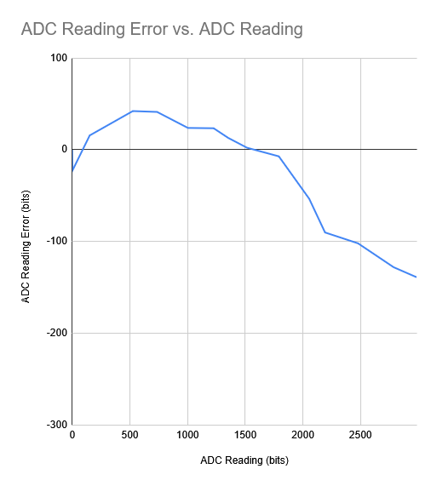

Without characterization the voltage is hovering around 3.175 to 3.183 V. +/- 4 LSB. 58 to 56 C. 1 degree of hysteresis might not be enough.

Multimeter reads 3.25 V. Error graph tells us to expect ~ -0.16 V. We’re seeing half of that. I’ll do another characterization

The 1602A display can’t source enough current from the USB port, so the 5V rail is around 4.6V. This is low enough that the contrast isn’t high enough for the pixels that we can’t see anything. I should design around this in a rev 3.0 if I do it. Idk how do maybe use another voltage regulator for VUSB to 5 V?

So far these are the readings:
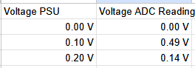

Exceptionally erroneous. This is using my Reflow Oven firmware that translates directly into a voltage.

I’ll use pin PA1 to compare, maybe it’s just that the pin is fucked.

I was using %d.%02d to print. This meant 58 mV came up as 0.58 instead of 0.058.

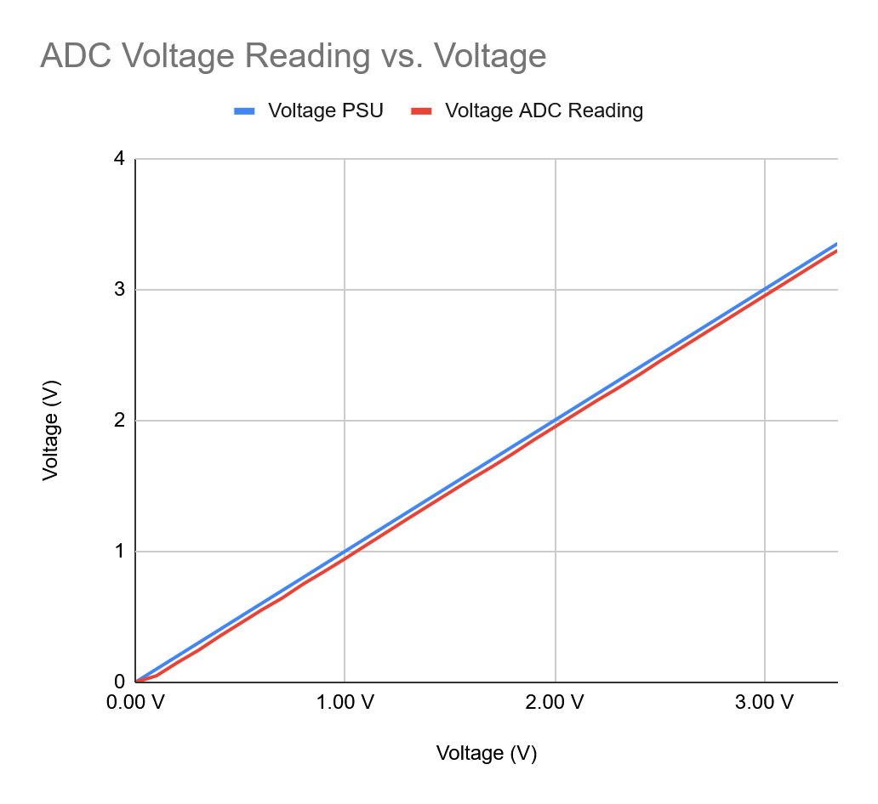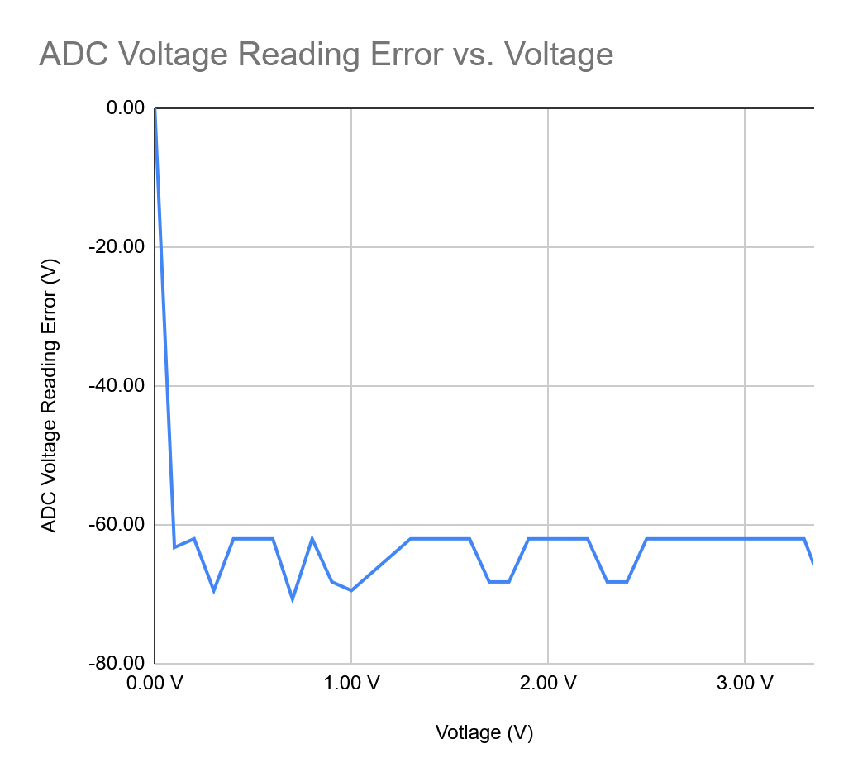
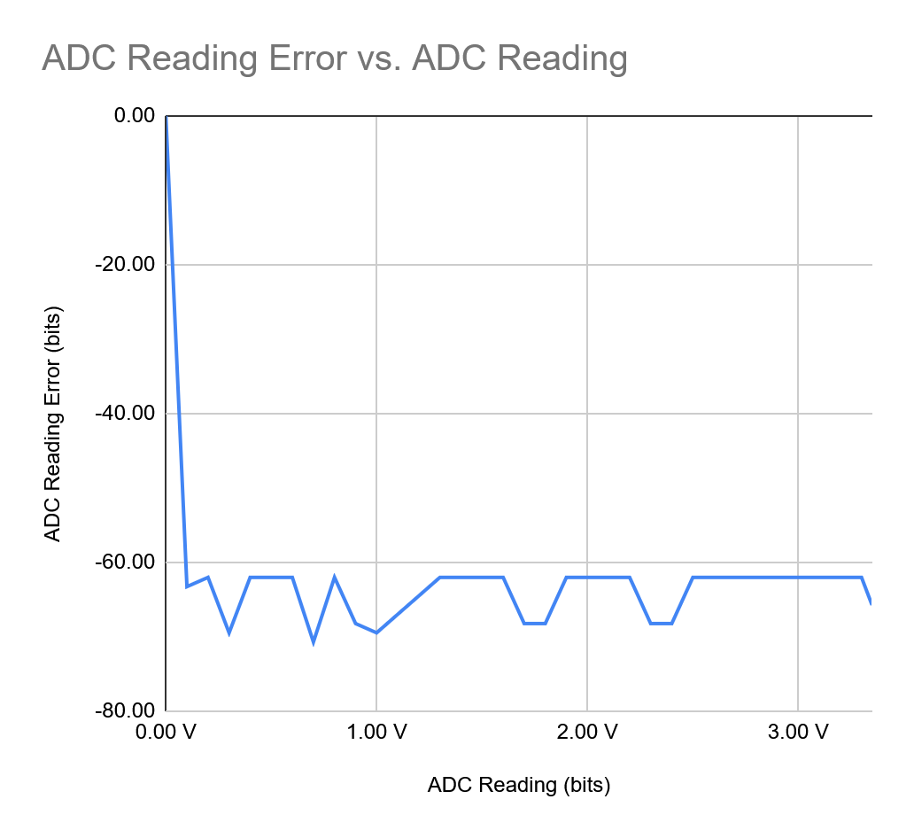

Constant ~50 mV error. Great failure mode! Why!!!

Add 65 LSB in firmware to make it accurate.

For SOP of my reflow oven I’ll have to add that you before you start it’s a requirement to confirm ambient temperature reading is correct.

Also, the 0 V reading is correct. With my adjustment it’ll be reading -50 mV, which is actually incorrect. I’ll just assume we never get that low. The voltage divider should stay high anyway, never around 0. Subtract 65 LSB.

Now reading with a multimeter I get 3.24 V and the ADC measurement is floating around there, maybe 3.23 V. Good enough range.

Currently multimeter is reading 97 kOhms, code is saying 44 kOhms, voltage is ~3.23 V.

At this level, a 10 mV error counts for ~10 C error.

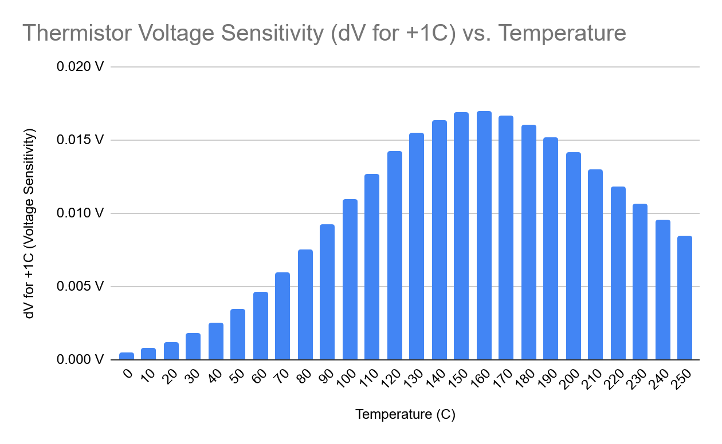

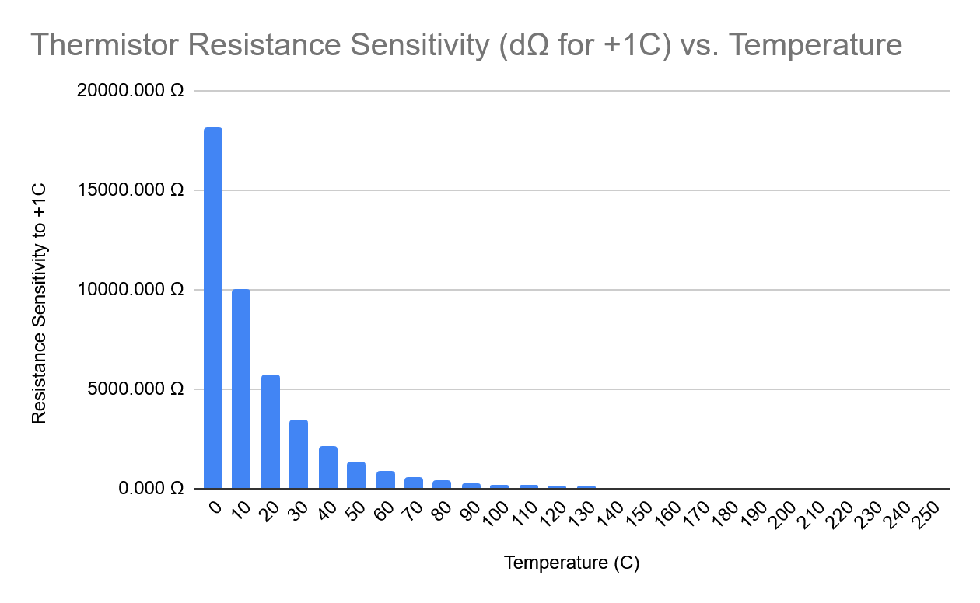

At 20 C, a 1 C error means ~5.5 k ohm error.

Our potential 10 mV error manifests as a ~8 C error. So ~40 ohms.

This error decreases as we get to higher temperature because of how I setup the voltage divider (slew rate of voltage is greatest when R1 = R2).

I’m getting an 8 C error by assuming we have a 10 mV error, then counting how many 20 C bars in chart 1 above (voltage sensitivity vs temp) we can fit until we hit 10 mV on y axis. Then, multiply the 20 C bar on chart 2 (thermistor resistance sensitivity) by how many degrees C error we have.

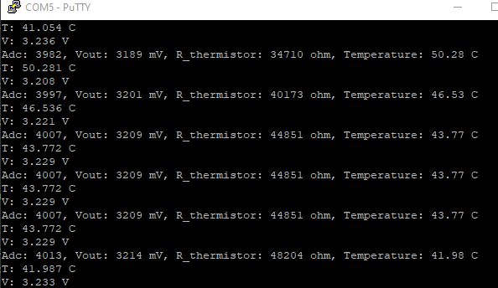

Hold up a second, our current temperature error is about 20 C. 2x worse than I guessed.

Even at R1=R2 we’ll have greater than 1 C error (maybe 1.25 C).

I’m fine with this, lets go for it. Full 1.35 kW power!!!!!

My god 2 horses!

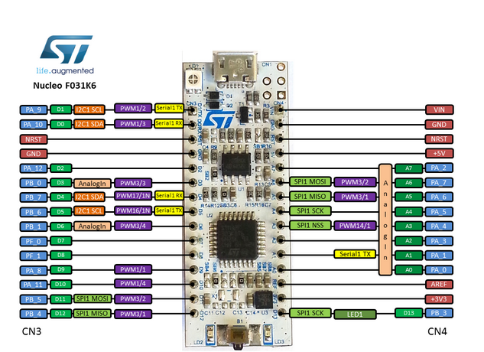

Current pinout:
- 3.3 V
- GND (Between VIN and NRST)
- D6 (PB 1) for ADC
- GND (Between PA 10 & NRST)
- D11 (PB 5) for SSR GPIO high

Firmware:
- Struct describing a state (exit condition, target temperature)
- Step between states

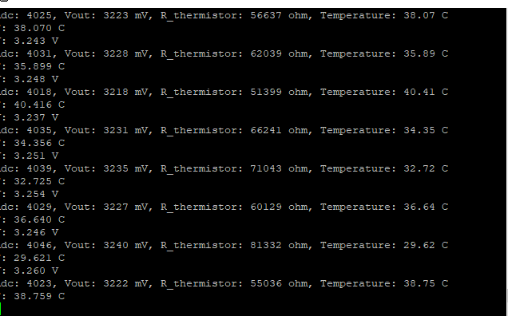

Looks like temp error got lower, ~15 C.

First test complete, FSM state switched like planned.

However, temperature is stuck at around 150 C now.

Resistance is ~90 kOhms. Plugged it back in and same result.

With multimeter, the voltage is actually ~1.6 V. Strange!

When the tap on the voltage divider is unplugged, the voltage returns to normal (~3.25 V). Maybe the ADC pin is fried? Shorted to something? I’ll try putting a power supply between it and GND to see if current flows.

Hope with a power supply to that ADC it draws 0.00 A and hits about the right voltage (+/- 5 mV avg).

The voltage stays the same if the STM32 is reset as well. Time to use multimeter in current mode.

~1.4 mA is going into the ADC pin, this is certainly what is ruining measurements. Maybe the ADC has been ruined? Time to try another pin, then another ADC peripheral if one is available.

That’s the only ADC pin available because the display takes all the rest.

I’m using PB0 and reassigning D2 (display GPIO data 2) for the display to the old pin, PB1.
0 A and proper voltage & temperature reading (well, 32.5 C but mostly proper).

Now trying the original config. Again ~1.4 mA but wrong voltage and temperature reading. ADC pin is fried. I won’t be able to use the display then. Oh well.

Now, D3 (PB0) is the voltage tap.

Sep 11 2025 - Code & First Run
It worked completely beautiful

FSM_State states[] = {
// duration (s), target temp (C), exit on temp reached, heater enabled
{5, 0, 0, 0},
{5, 100, 0, 1},
{0, 100, 1, 1},
{20, 100, 0, 1},
{0, 150, 1, 1},
{20, 150, 0, 1},
{0, 200, 1, 1},
{20, 200, 0, 1},
{0, 240, 1, 1},
{10, 240, 0, 1},
{999999, 0, 0, 0}
};

Test 1

Some notes on run 1:
uart_data_2025-09-11_21-11-52.csv

~650s is when I opened the front of the oven. ~820s is when I took the thermistor out.

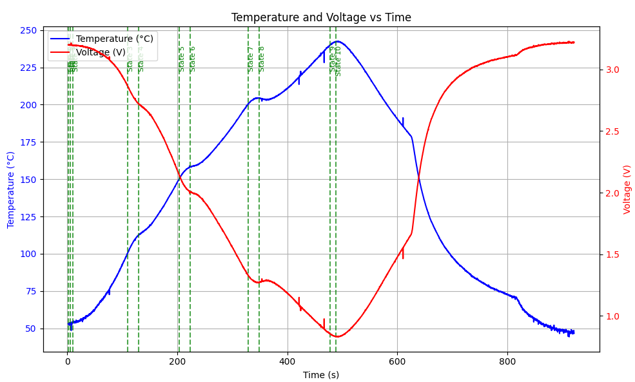

Ideas for improvement:
- Plot in real time (so cool it’ll be)
- PWM heating element to get better approach to target temperature (right now we skip way high)
- If a value is out of the mean of previous 5 values (+/- 1 C maybe), then ignore it
  - Alternatively, require at least 5 values above a given threshold to change state
  - This is to fight against noise

Test 2
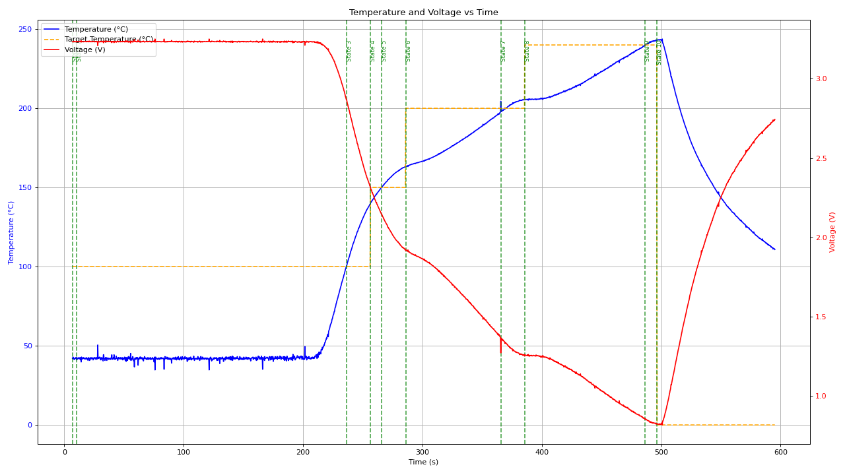

I forgot to put the thermistor back in until ~210 seconds.

Test 3

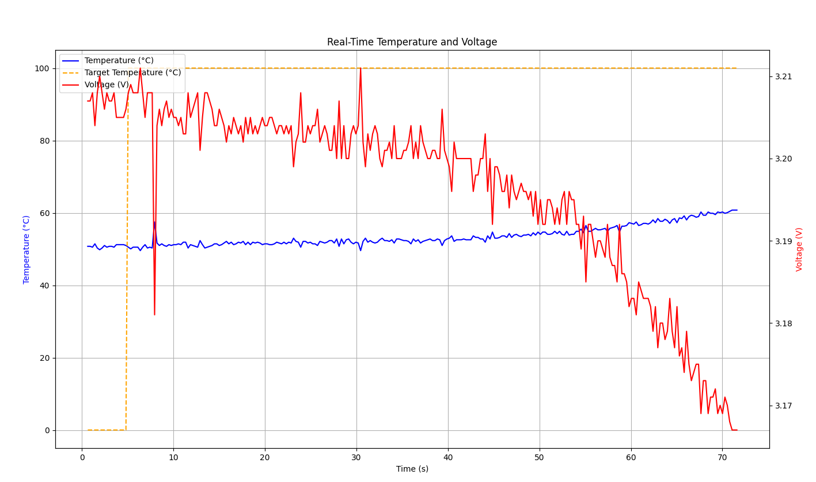

At ~28 seconds here is when the heater was enabled.

Test 4:

Real time data!

I played around with the door towards the end a little bit, and taking out the thermistor and putting it back in. Now I must sleep, need to be energized for first date tomorrow evening. The Moon is rising over the horizon through the clouds!!! Need to run AC so room is colder for sleep, shower now.

The exponential / logarithmic temperature relation is cool. Math / theoretical concepts IRL is always very cool.
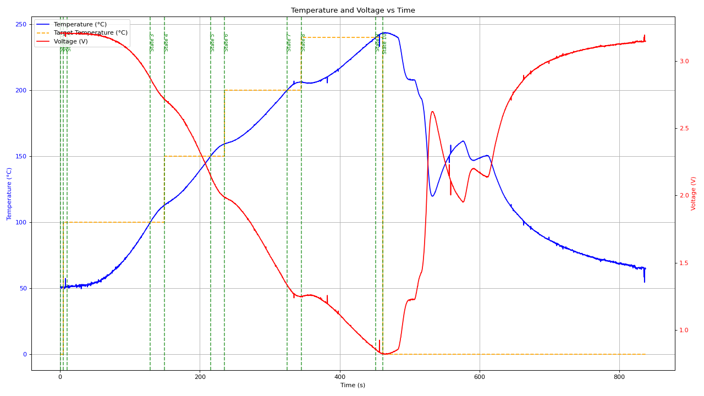

Sep 14 2025 - It Works

Reflow Oven SOP:
- Ensure the proper reflow profile is flashed onto the STM32 and that the thermistor is installed in the oven.
- Set top oven dial to toast (max temperature), middle dial to toast, and bottom dial to 30 minutes.
- Plug in the reflow oven and plug a USB into the STM32. Ensure the UART read script COM port matches the STM32 COM port.
- Hold down the reset button on the STM32 and start the UART read script. (This way it’ll start at t=0)
- Watch over the reflow oven as it operates.
- When the target temperature goes to 0 C, open the door half way. As the slope of the temperature graph beings to decrease, open the door all the way.
- Take your PCB out when the temperature has reached a safe level.

Note that at the low-end, the temperature reading is off by ~10 C, so it reads ~30-40 C normally.

Modelling

Modelling A Reflow Oven
Christopher Kalitin

Thermal Resistance & Capacity
https://chatgpt.com/c/68c46442-bf20-8331-8f55-4851e38a3472

Thermal Resistance

R = V / I

R_{th} = dT / dQ
R_{th} = Thermal resistance (K/W)
dT = K
dQ = Heat flow (W)

R_{th} = L / kA
L = length (m)
k = Thermal conductivity (W / mK)
A = area (m2)
This simplifies to K/W

In this analog, R is still resistance, potential is either voltage or temperature, and flow is either current or power.

Thermal Capacity

C_{th} = mc
m = mass (kg)
c = specific heat capacity (J/K)

This is equivalent to:
C = Q/V

Where:
- V = T (Voltage, temperature)
- I = dQ (current, heat flow rate (W))
- Q = Q (Charge, heat energy)
- C = C (Capacitance (F), thermal capacity (J/K))

I = C * dv/dt

Is equivalent to:

dQ = C_{th} * dT/dt

Heat flow = Thermal capacity * rate of change of temperature

dQ is really Q dot, which is dQ/dT so slightly bad notation that I’ll have to solve later with nice Google Docs equations.

Energy Balance

Rate of change of stored thermal energy, equal power in minus power out.

Very simple:
C * dT/dt = P - (T - T_{th})/R

Note that above we saw dT/R = P, like V/R = I

C = Thermal capacity is [J/K], so C * dT/dt = J/K * dT/dt = J/dt = rate of change of energy versus time = power.

Note that tau = RC still applies, you still get time constant!!!

Rate of change of stored thermal energy is actually just power.

